Date: 13/07/2020

How to import supplier e-invoice data file from xtranet to ABSS purchase transaction module

1. As per normal procedure, go to “View Invoice” menu to Print a copy of the invoice with approve the e-invoice thereafter. The hard copy of invoice will be filed to unpaid creditor file after we have checked and confirmed that the e-invoice data has been imported to ABSS purchase transaction module successfully.

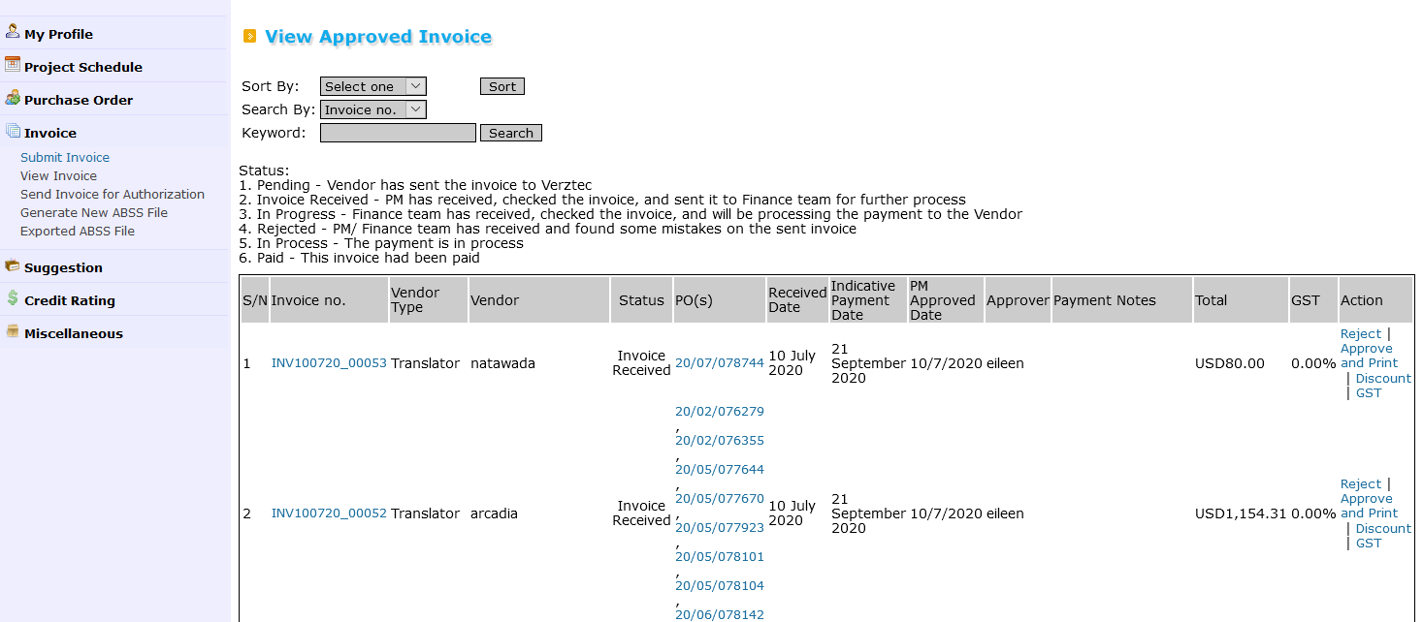

1. At Invoice Module, there would be 2 New Sub-Menus created under this module now.

* **Generate New ABSS File** – This is use to generate invoice data file into ABSS file in csv format (excel format first)
* **Exported ABSS File** – After the invoice data file is being imported to ABSS, the data file will be moved from Generate New ABSS File menu to here as past record

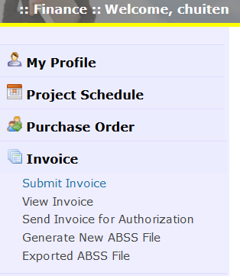

1. Click on “Generate New ABSS File” and you will see there is a list of e-invoice data file show at below

* Check on the box near to S/N as to select all invoices for importing
* Click “Generate All to ABSS” box at the bottom for generating in Excel format file

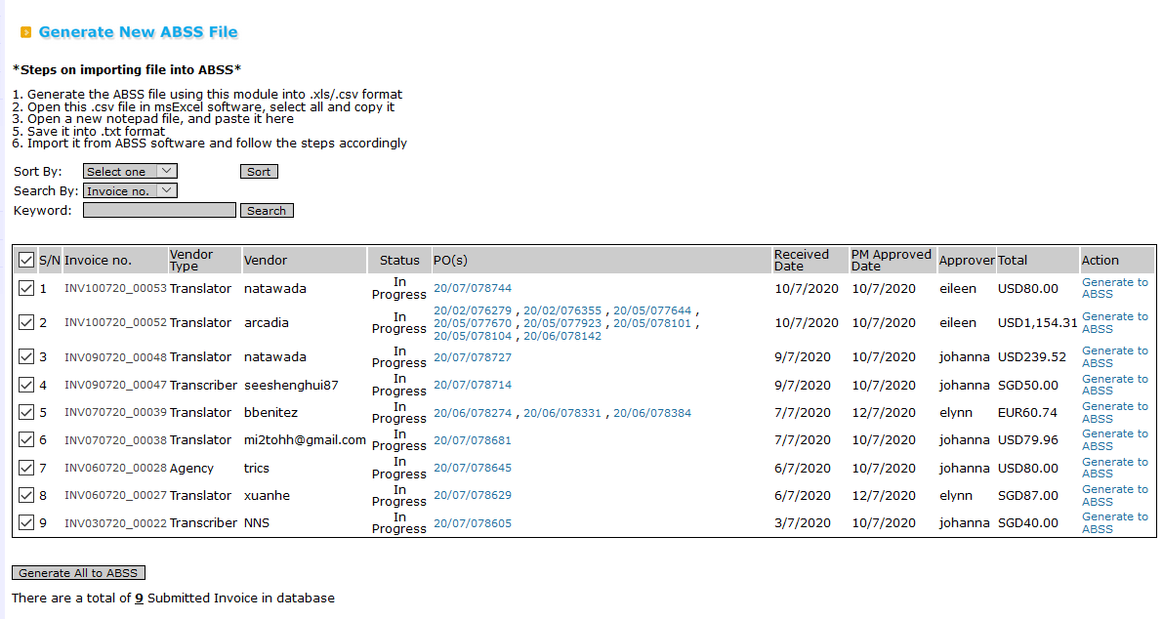

1. The Excel file will be download at top right Arrow there

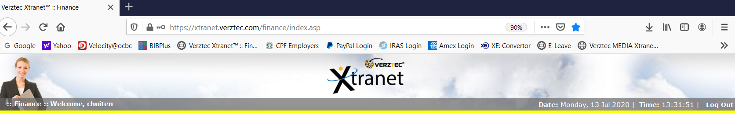

Save the file name by default in Excel Format. We will be using this excel file to copy and paste to “Notepad” 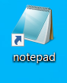for the conversion from excel data file into text data file (.txt) This is because ABSS only accept text data file for the import data

Do note that for each time we can only select 10 invoice transactions, should you have more than 10 transactions, do the first ten and repeat the same steps for the next 10 invoices

1. Open your Excel file that you have generated from xtranet, highlight all the transaction in excel and copy to NotePad and save the file name with .txt Now, we are ready to import the text file to ABSS



**A Sample of the 10 nos of e-invoice text file format that we are going to import to ABSS**

1. Login to ABSS as **Single user ONLY**. Back-up your ABSS data file before you perform the data import (IMPORTANT)

At ABSS, Click -> File – Import Data – Purchase – Service Purchase (I couldn’t print screen of this step)

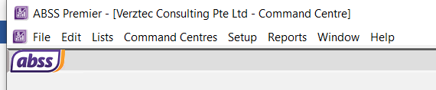

The box below will display. Just Click “Continue”

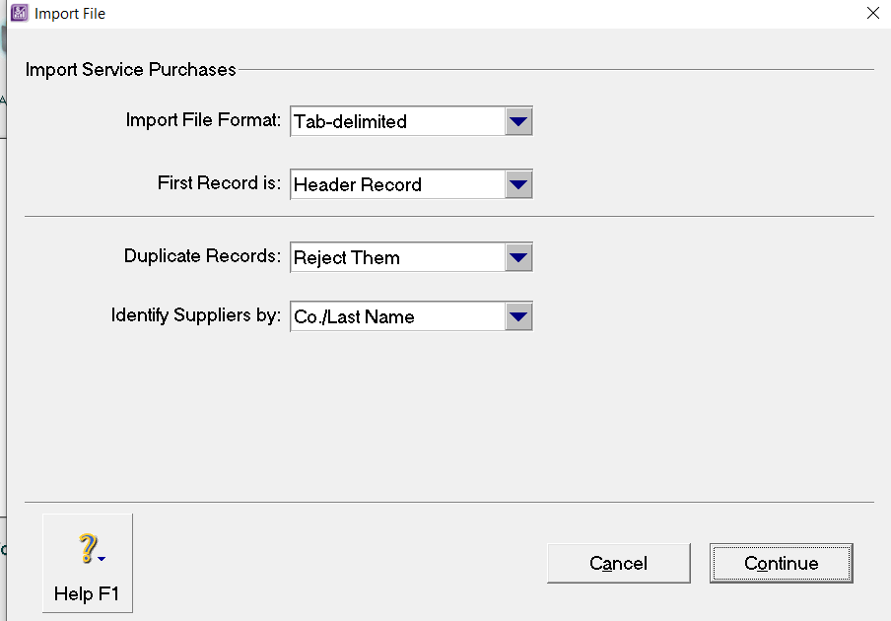

1. Insert your text file that you had saved previously. Click “Open”

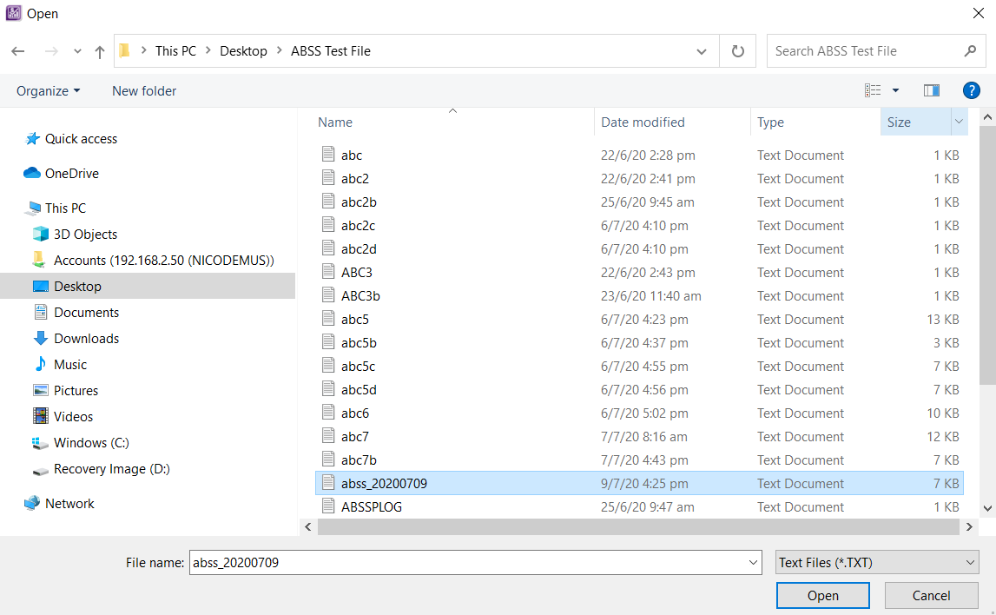

1. The box below will display. Select “Match All”

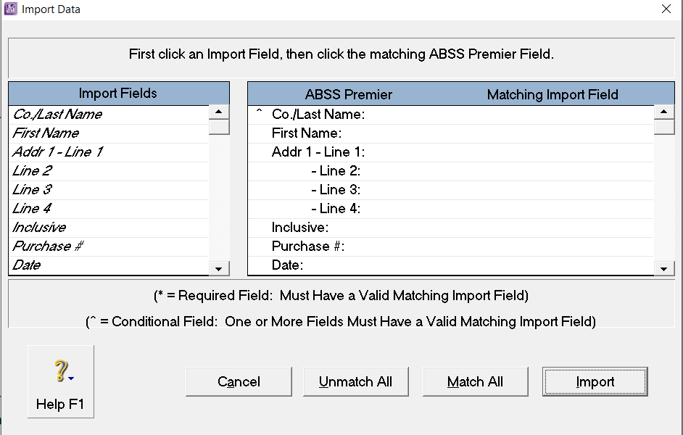

1. The “Matching Import Field” will be auto filled and displayed. Click “Import”

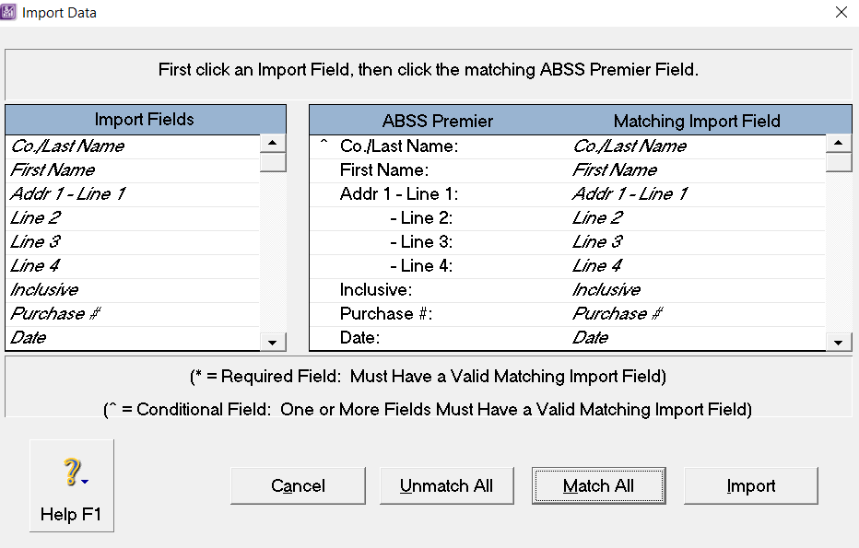

1. The box below will display after import data is completed.

Out of 10 invoices imported, there were 8 records imported with warnings. This is correct as the import text file is designated without the inclusive of foreign currency exchange rate generated from xtranet. What we need to do is to open the respective supplier account at ABSS to check the invoices whether it is recorded successfully as compared to the hard copy we have printed

For the 2 records skipped - We have to check these 2 records for the reason why it was not imported to ABSS by opening the “ABSSPlog.txt” file follow the path shown at C drive

Since I am using the trial ABSS data file that I copied to my “C Drive” for testing, therefore we could locate the log file in the C drive. However, when we import the data into our actual ABSS data file stored at Account Server, then we should be able to locate the Log file at Account Server drive.

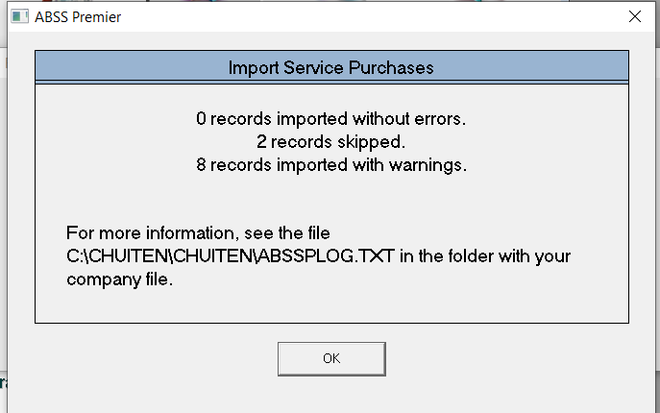

1. Open the Log file to find the detail of the 2 skipped records.

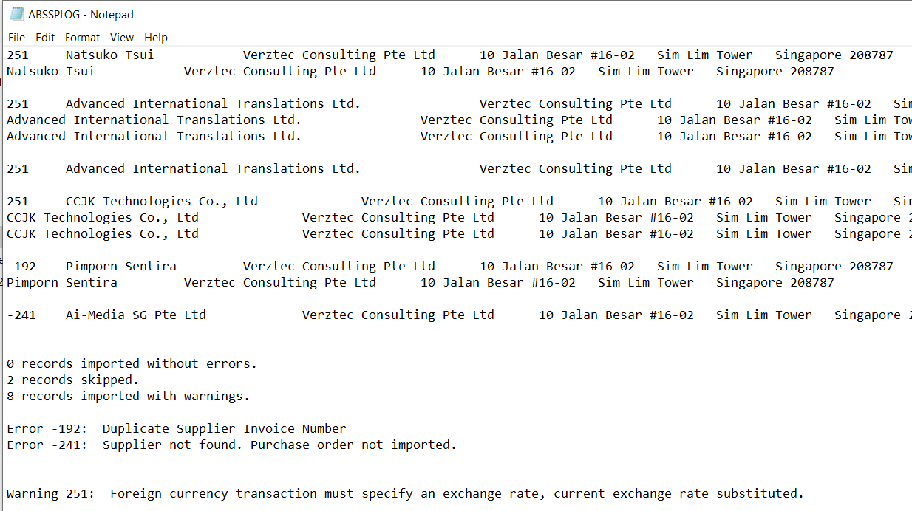

In this example

* Error 192 – Duplicate Supplier Invoice Number

Supplier Pimporn Sentira already have the Supplier invoice of “NA” recorded in the past invoice at ABSS purchase data already. Hence a duplicate invoice error was prompted.

In this case, we would have to record the supplier invoice into ABSS manually base on the hard copy we printed on hand.

As usual, the NA stated in the supplier invoice will replace key for the #1st PO number in the supplier Inv# field in the ABSS. This can avoid the future similar error occur

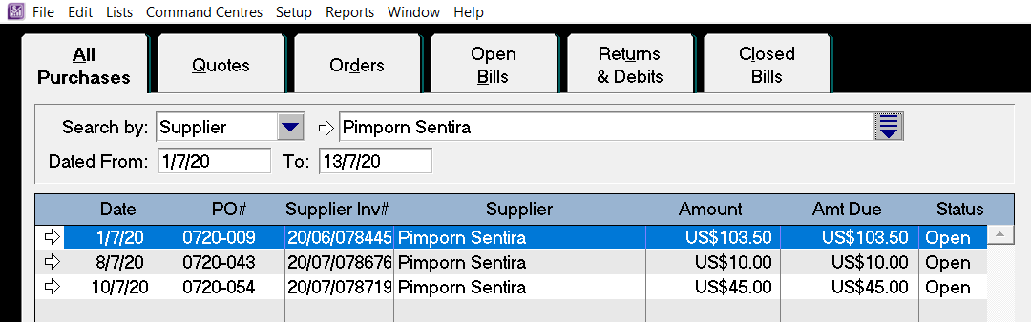

* Error 240 – Supplier not found

This is New Supplier which we do not have New Supplier Card ID created in our ABSS data before.

Hence, we would have to create new card ID in ABSS and record the invoice manually.

To reduce this error, we could just create the New Supplier Card ID at ABSS data file first based on the hardcopy of invoice printed on hand before we perform the data import